Introduction

This project is manly open source. It introduce to how to detect the error from grammar.

Purpose

The present Grammar Detection Software Requirements Specification (SRS) document was prepared as

the next incremental step after the grammar detection Scoping and Requirements (S&R) document,

The present document is describe how to design and what are the things to required for the development of the Grammar Detection. The SRS captures and describes the desired behavior of the end product in a wide range of situations. Some of the non-functional requirements in this document were taken as is from the scoping document and can still be refined.

Scope of the Grammar Detection

As described in the Grammar Detection (S&R) document, the Grammar detection is a tool to, regional or thematic level, including the possibility to offer access to additional sources of information. The primary users of the this software is the developer and then uses in public it uses in manly two level first developer and public this application find your mistake in sentences.

Product perspective and historical background

This appliocation is developed in **2009** by Ukrainians Alex Shevchenko, Max Lytvyn, and Dmytro Lider name as Grammarly. The backend grammar engine was written in Common Lisp. The app is owned by Grammarly, Inc., of San Francisco, California. In May 2017, the company raised $110 million in its first round of funding. But in this project we are doing grammar processing only.

Document conventions

The main type of convention used throughout this document helps to represent the level of priority of the different software requirements. These priorities are established in function of many factors, including those identified in the GD (S&R) document, represent the reality at the moment this document is prepared.

In the functional requirements section, to keep consistency with the GD (S&R) document applying for correction of your sentences and find error.

* User Accounts:

User accounts are password protected (Utilization of In Common Federation will considered in future phases of requirement)

Password reminders and resets are handled by the website.

With the exception of system administrators, all user accounts are tied to an institution

* System Security:

Public has read-only access via website (he can’t change my website document).

Actor Survey

This section lists the different actors GD instances shall interact with: end users (primary actors) and actors from which the system needs assistance to satisfy a goal (secondary actors).

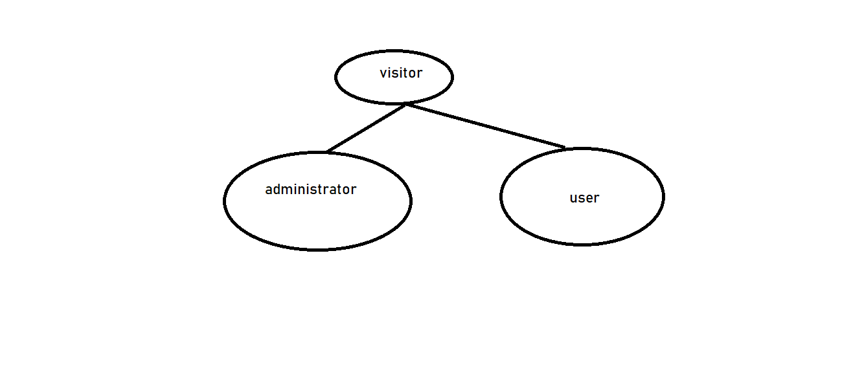

In the Non- functional requirements section, to keep consistency with the GD (S&R) document applying for correction of your sentences and find error but you cannot change setting of software .

* This application only used by user and can’t be modify.
* Recover Data

User can recover its login detail and he can change the password user name.

* Portable

It can apply in many site as you want.

* Assumptions and Dependencies

The operation of the system depends on GD registry to allow addition of new extensions.

* Security Requirements

The system shall retain an audit log for all successful operations.

* Scalability Requirements

The system should be able to store your details and after use erase it.

* Operating Environment

The system shall operate with the two latest major releases of the following Web browsers: Firefox, Opera, Chrome, Internet Explorer etc.

The system shall operate on a server running Linux, Windows server or Mac OS.

Application

* Used in mail correction.
* Used in writing a book with proper sentence it can easily find your mistake.
* It uses in searching in web browser.